FIT3138 Assignment 1 Part 2

Production Planning and Supply Chain Management

Data Sheet

Name : Jason Ching Yuen, Siu

Student Id : 31084222

Tutorial No : …02……………

SAP Id (LEARN-###) LEARN-020

Instructions :

1. Complete your details above.
2. Copy and paste the five screenshots where indicated. Screenshots must be clear and easily readable.
3. Write you reflective essay on the last page (approx. 300 words)
4. Save the document as AAAA-9999999 Part 1.docx (or .pdf) where AAAA is your last name and 9999999 is your Student ID e.g. Smith-3678999 Part 1.docx
5. Upload the document to the submission link in Moodle.

Step A: Material Component Overview

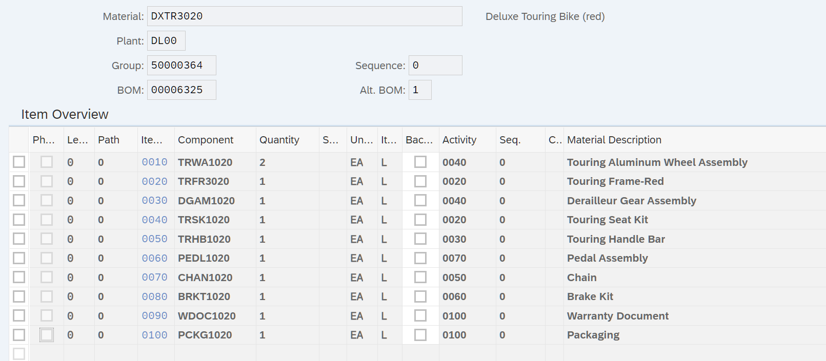

Step B: Change Rough-Cut Plan

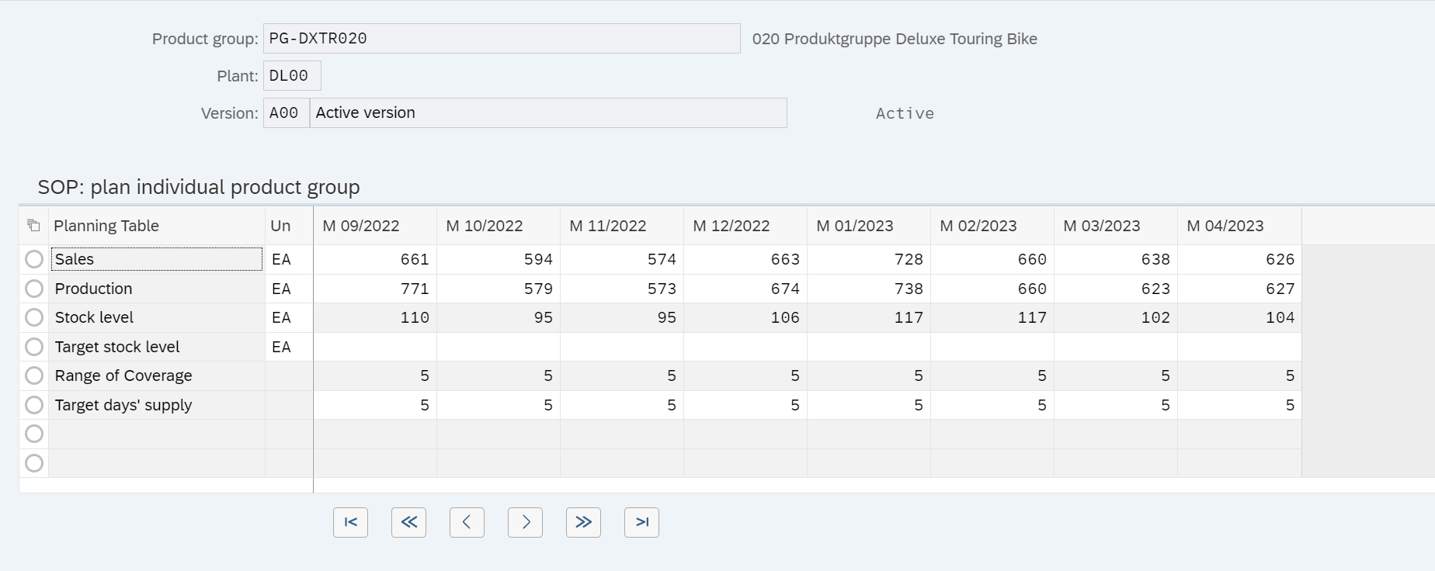

Step C: Pegged Requirements

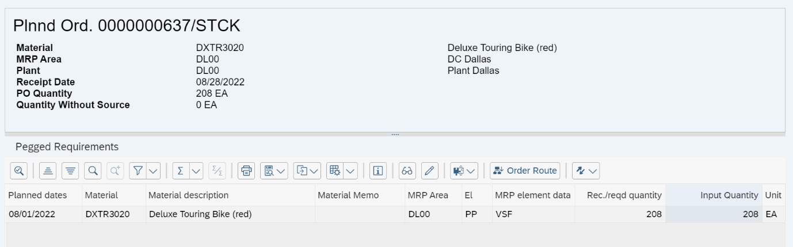

Step D: Target/Actual Comparison

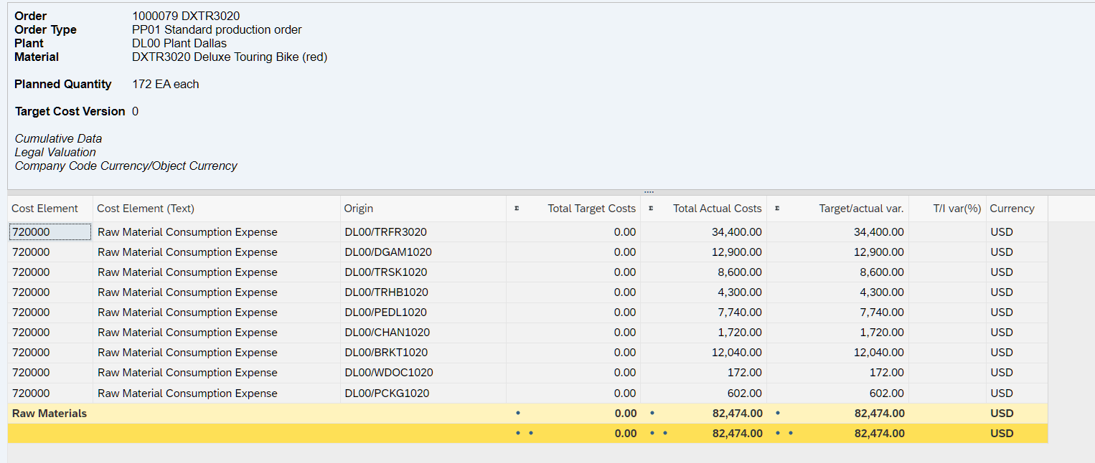

Step E: Orders: Actual/Plan/Variance

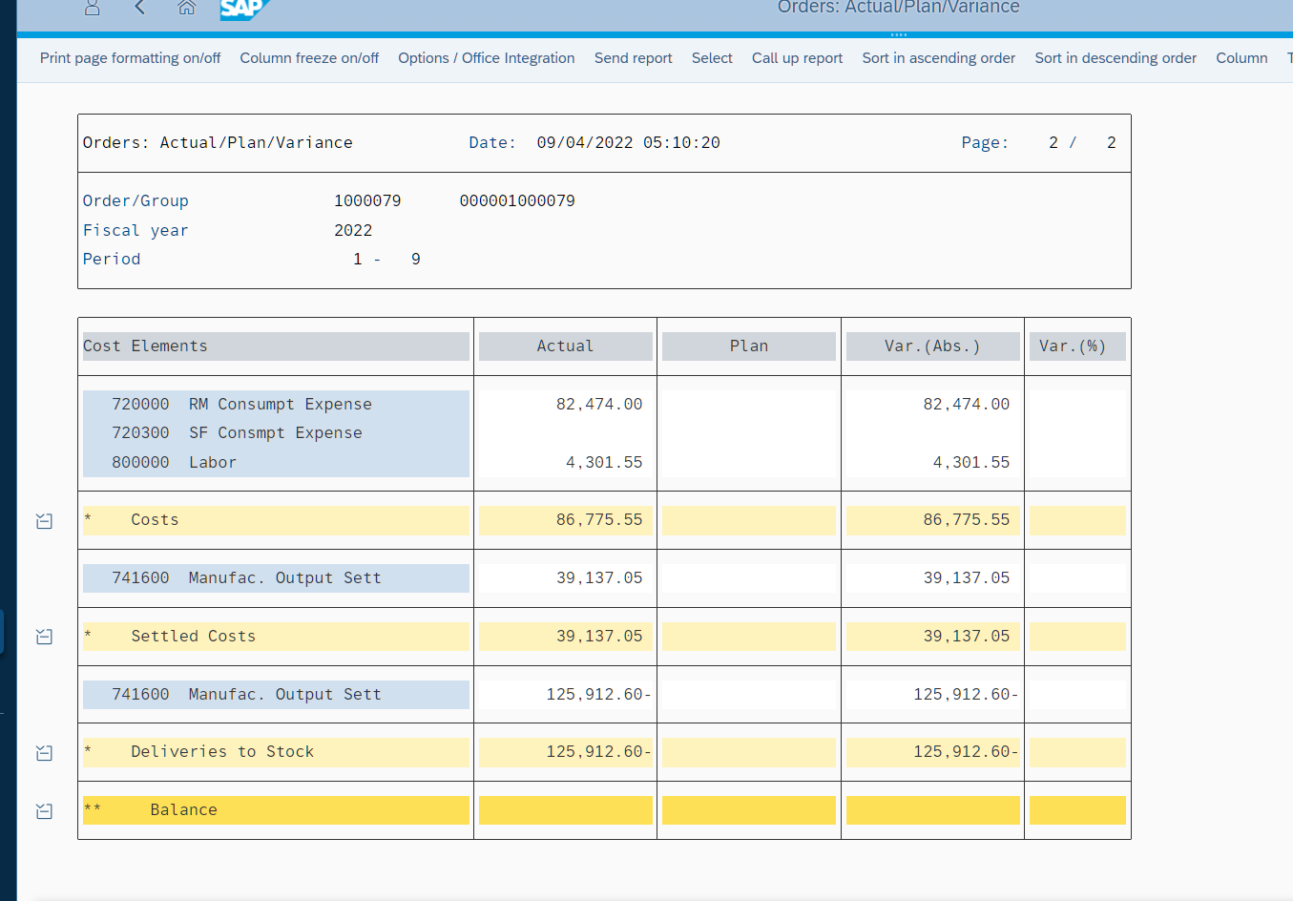

Reflective Essay

Having a great idea for a product is one thing. Turning that idea into reality is another. To create real business value, regardless of how fancy your product is, you need a manufacturing and logistics system in place. Supply chain management (SCM) is a network of people, businesses, technology, and resources that come cohesively to turn into reality. *“Cohesive”* is a keyword because improper management could cost you dear. SCM answers *“Why to produce”, “What to produce”, “How and how much to produce”,* and *“Who to produce”.* We reflect on how the Production Planning module work cohesively in increasing efficiency in SCM.

The core benefit is to have Master Data in SAP PP (e.g., Material master, Work centre, Routing, BOM, etc). This centralised master repository allows Global Bike Group (GBG) to procure the raw materials, produce the finished product, and create a sales order in synchronise manner. Material masters includes information on materials that GBG procures, produces, stores, and sells. So, here explains how these data help optimise the resource utilisation and production inventory.

For production execution, such information helps build a BOM — a list of components with quantity needed to produce and assembly the bikes; it helps define a sequence of operation performed at the Work Centre. When working on the system, I realised how powerful it is to have a consistent material flow to convert a planned order to production order in MRP, controlling the scheduling, capacity, and costing optimally.

For production planning, after having sales requirement from Jun Lee — my supervisor, a SOP plan consolidates data for forecasting future sales and production levels. Forecasting is important because knowing market demand help estimate “how much to produce”.  This makes the inventory management lean and agile by preventing redundant material reacquisition and reducing days-in-inventory — the most common bottleneck in company, shipping orders according to promised delivery dates results in increased customer satisfaction.

In conclusion, this module helps us optimise the resource utilisation and production inventory.